Donating to MAPS via Paypal.com
Using an iOS system

Step 1: Download the PayPal app

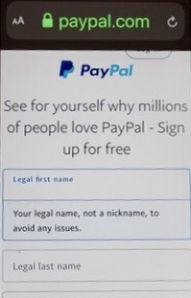
Step 2: Create a personal account

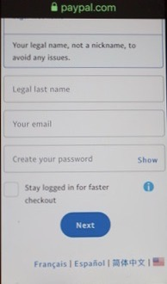
Step 3: Create a password

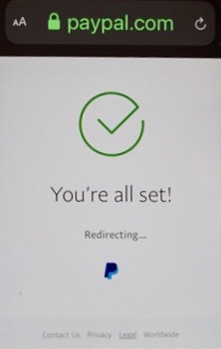

Step 4: The app will notify you when your account is officially set up.

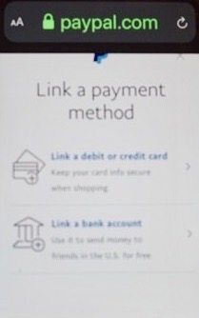
Step 5: You will be required to link your account to a debit, credit card, or bank account.

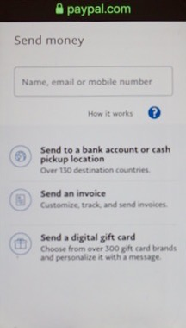
Step 6: To make a MAPS payment, type in the name/email/mobile number prompt: Maps4families@gmail.com

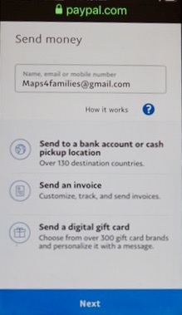
Step 7: This is what the screen should look like after you type in the email address.

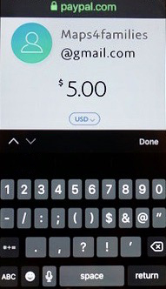
Step 8: It will then prompt you for the amount you want to contribute. Type 5-0-0 for $5.00.

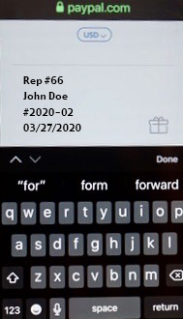
Step 9: IMPORTANT: As you scroll down from entering the amount,
please enter this information as a notation:
a) Your MAPS representative # _ _ e.g. 66

b) Your First/Last Name e.g. John Doe
c) Death Notice Number(s) e.g. #2020-02
c) Today’s Date _ _ / _ _ / _ _ _ _ e.g. 03-27-2020

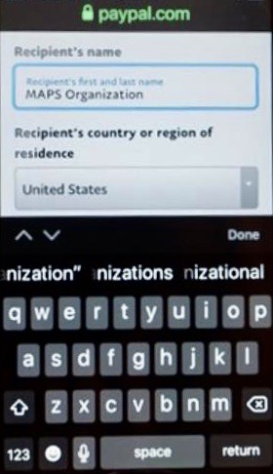
Step 10: Recipient’s Name: MAPS Organization
Recipient’s country or region of residence: United States

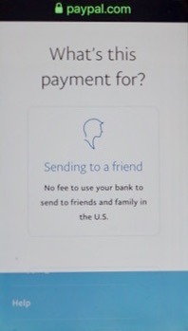
Step 11: You will be prompted to select what this is for.
Select “Sending to a Friend”

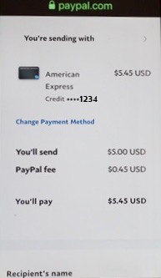
Step 12: Once you hit done/submit, then you will receive notification
that a payment has been made. Please note that there may be a small transaction fee (in this case, it was .45 cents).

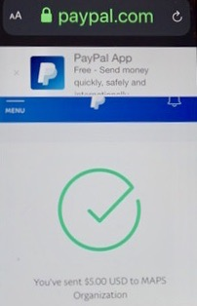

Step 13: When you advance to the next page, it will notify you that your donation was successfully sent. Now, depending upon which email you used for your contact information, you will receive an email confirmation of this payment.

Step 14: Upon receiving email confirmation from PayPal, please send email receipt to: your MAPS representative & Jacquita.Parker@faa.gov

